UNIT 4: CLOTHER, WEATHER AND SEASONS
LESSON 2: THE WEATHER PUZZLE

- Ponoviti nazive za dijelove tijela - Kahoot
https://www.youtube.com/watch?v=WX8HmogNyCY
- Ponoviti nazive za odjeću
- Ponoviti nazive za dijelove tijela uz igru (za ovu aktivnost su potrebna dva uređaja, npr.tablet i mobitel (na tabletu se prikazuju pitanja, a na mobitelu učenik odgovara). Ako učenik nema mogućnosti odigrati ovu aktivnost, može ju preskočiti. Kad se otvori link, potrebno se kliknuti: play as a guest)
https://create.kahoot.it/share/ded7f02f-d9de-425c-af55-41181c555269
- Naučiti nazive kojima imenujemo vremenske prilike
https://quizlet.com/_88bsd1?x=1jqt&i=2qld1n (lozinka: osjakovlje)
https://www.youtube.com/watch?v=CXKj7bm4Ops
https://www.youtube.com/watch?v=Jn7uAsLWXpk
- u/ 45 zad. 5 – poslušati zvučni zapis (CD 40) i spojiti puzzle, a nakon toga samostalno pročitati tekst.
- Poslušati pjesmicu Rain, Rain, Go Away
https://www.youtube.com/watch?v=HRJUGl1a1t8
- Rb/42 – 43 – riješiti 1,2,3 i 5. zadatak

IZGLED PLOČE:
Schoolwork
THE WEATHER PUZZLE
What's the weather like today? – Kakvo je danas vrijeme?
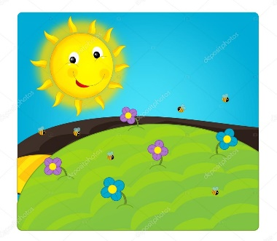 It is sunny.
It is raining.
It is snowing.

It is cold.
It is hot.

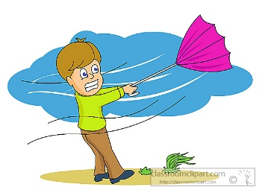 It is windy.

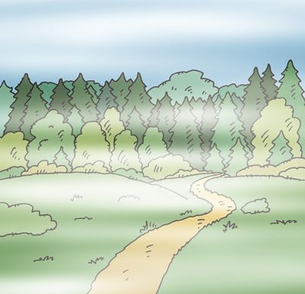 It is foggy.
It is cloudy.

It is stormy.

